**Project C: Windsurfing, Submarine and Fishing Rod**

Name: Yipeng Pan

NetID: YPK6670

Instruction:

There is a windsurfing board, a submarine, a fishing rod and big sphere slowly moving on the screen. Two light sources are applied, one is a head light moving with the camera and the other one is a fixed light located at the top of the origin.

User Guide:

Users can use the selector on the screen to switch between Gouraud/Phong shading and Phong/Blinn-Phong lighting. Besides, they can switch on/off the two light sources. Users use arrow keys to rotate the camera, and press W/A/S/D keys to move the camera and zoom in/out.

Moreover, users can press the digit1-6 keys to move the fixed light in the positive/negative direction of X/Y/Z axis.

In additional, users can input the R-G-B value of ambient, diffuse color of the sphere and click change button to change the color of the sphere, and input the R-G-B value of specular light to change the color of the light from the fixed light source.

Pictures:

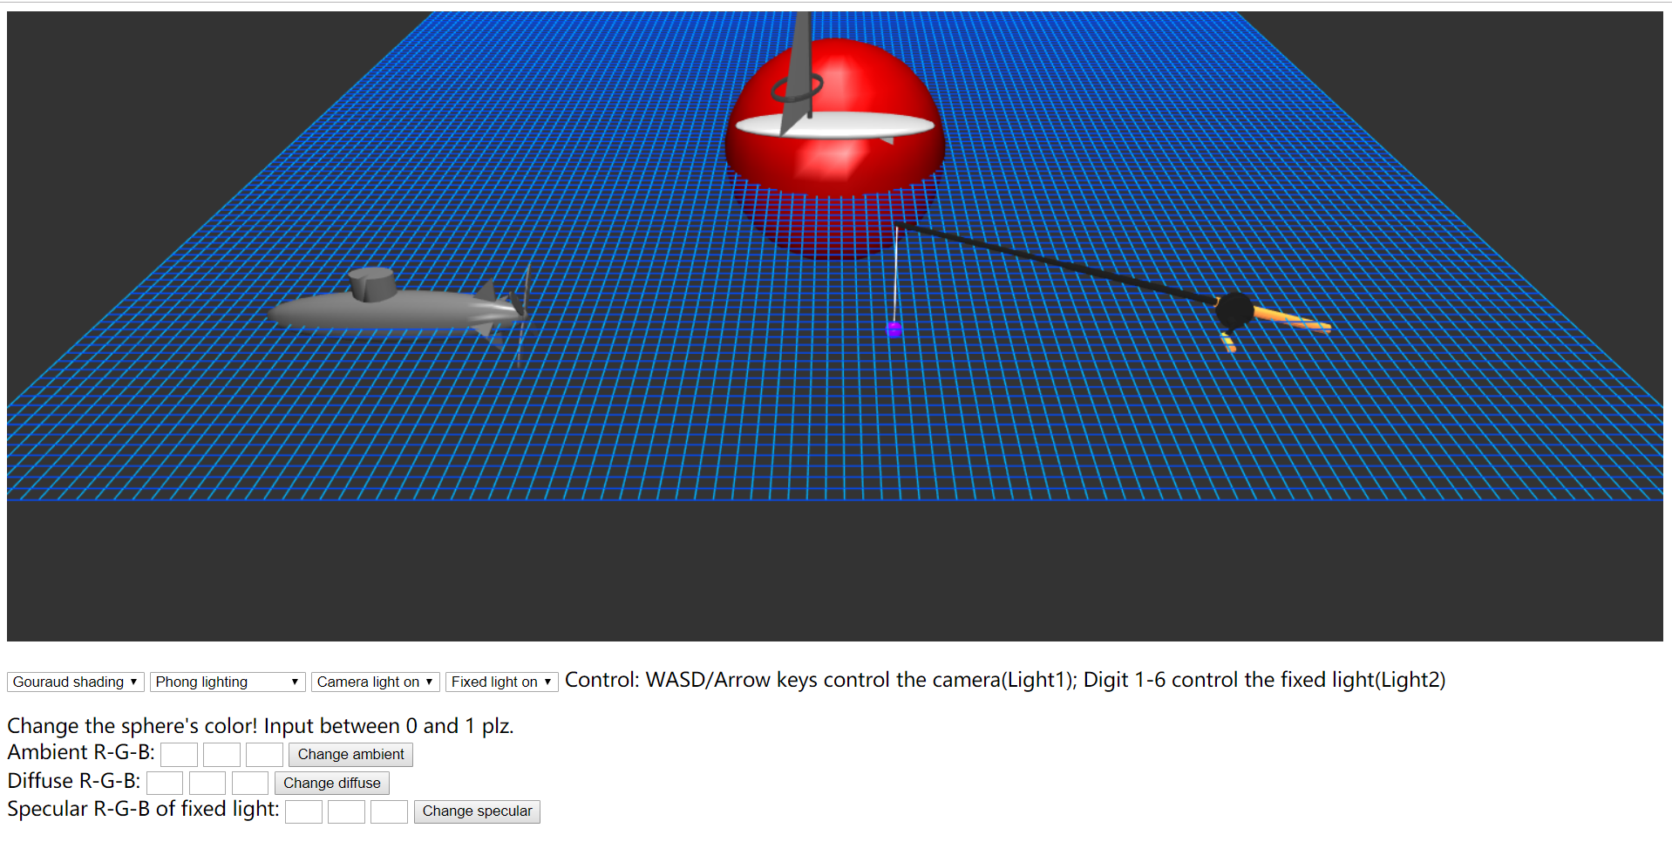

Figure Default scene

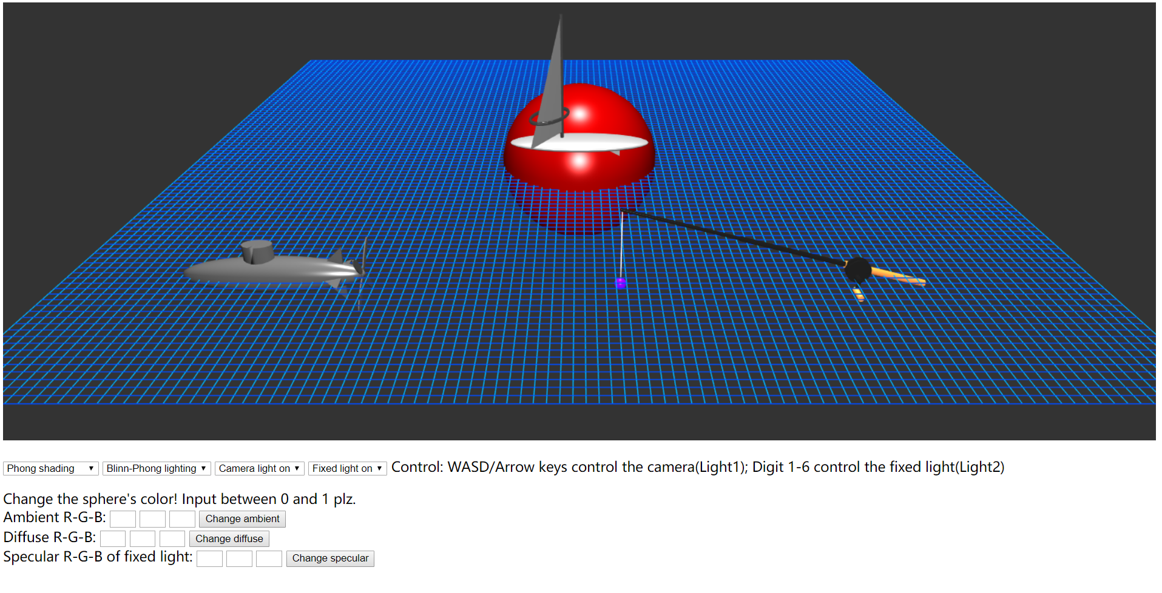

Figure Switch to Phong Shading and Blinn-Phong Lighting

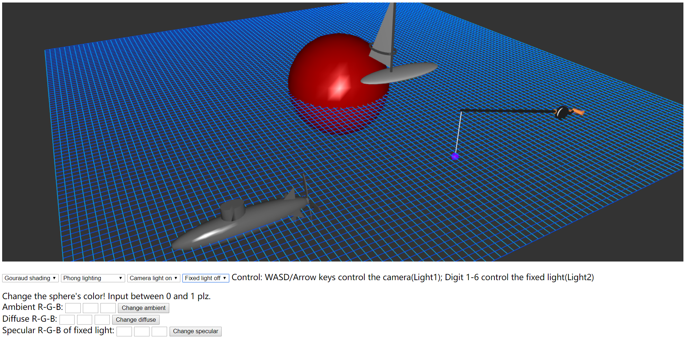

Figure Move and Rotate the camera, switch off the fixed light.

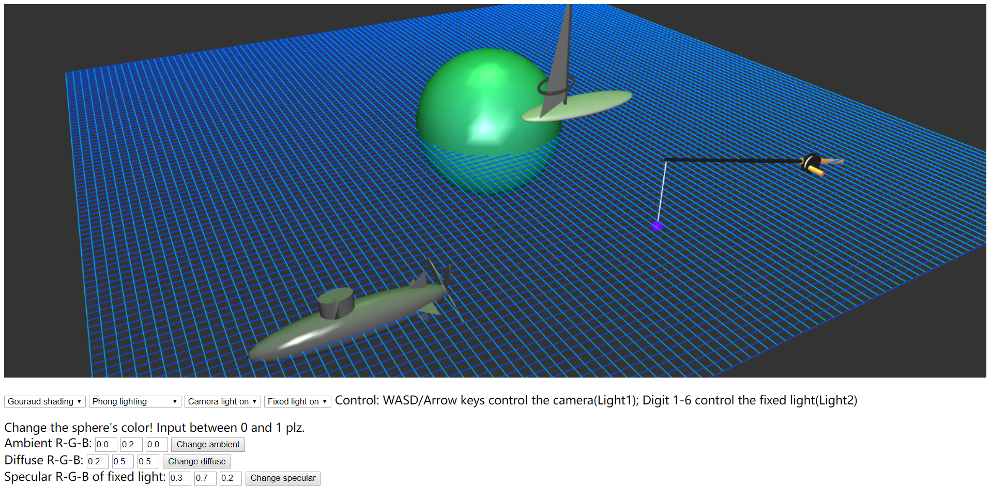

Figure Change the ambient, diffuse color of the sphere and change the specular light of the fixed light.

Scene Graph:

